**Objective**:

* Reduce ride cancellations and enhance the rider experience through product improvements.

**Approach:**

* **Pain Points**: Pain points refer to areas of the difficultes , frustration and problem user feel while using the app.
* **Rider Pain Points:** 
  + Driver Cancellation
  + Price Surges
  + Unclear Pickup Instructions
  + Poor In-App Communication
  + Safety
* **Driver Pain Points:**
  + Riders not ready
  + Pickup location frustration
  + Lack of control
  + Mismatch in Trip Types
* **Platform Pain Points:**
  + Cancellation feedback loop
  + No Personalisation in matching

**Proposed Features:**

* **Rider:**
  + Rider can cancel the cab within only a certain amount of time, like within 3 minutes.
  + Repeat Riders have a Priority in matching with the driver of a higher rating.
  + Feedback on why the Trip was cancelled.
  + Riders have the option to share the live location of the cab, along with its Driver with other people.
* **Driver:**
  + The driver will be notified if there are irregularities in the cab pattern of the user.
  + The user booking the ride has to mention at least one landmark from the driver can easily spot them.
  + If the wait for the rider is higher than 10 minutes, the driver can cancel the ride.
* **Platform :** 
  + The driver will have to fill out why the trip has been cancelled.
  + The driver will get a certain number of cancellations (no approval from the CC). After the number has been exhausted, the driver will not be able to cancel without approval from the CC.

**Key Issues:**

* High Cancellation Rate: Due to Surge pricing, rider uncertainty or driver ETA ,along with various other factors.
* Poor Communication between the Rider and driver: The Lack of a good communication channel between the driver and rider creates tension between the two parties.
* Lack of feedback loop on Cancellations: There is no feedback from the rider or the driver on why the ride has been cancelled.
* Safety: Safety is one of the most important considerations riders face while travelling (esp female riders)

**StakeHolders:**

* **Riders(Passengers)**: Core users affected by cancellations, key source of feedback and retention
* **Drivers**: Their satisfaction, efficiency, and trust in the system directly impact reliability
* **Operations Teams**: Can influence driver education and pickup-point optimisation
* **CC(Customer Care)**: Needs better tools to handle cancellation disputes or rebooking
* **Product & Engineering:** Supports ongoing experimentation and success metrics tracking.

**User Personas & Pain Points:**

* Persona 1 - Daily Commuter: Rider travels daily from A to B, and is really time bound because of this reason he/ she gets specially frustrated when the ride gets cancelled. Time is very important for them.
* Persona 2 - Tourist : Rider is new to the place he/she might lack the knowledge of the local language, they might need better clarity and better ETA.
* Persona 3 - Driver: Cancels the ride when it seems difficult or takes too much time for pickup or the rider is unresponsive.

**Feature 1: Smart Ride Assurance**

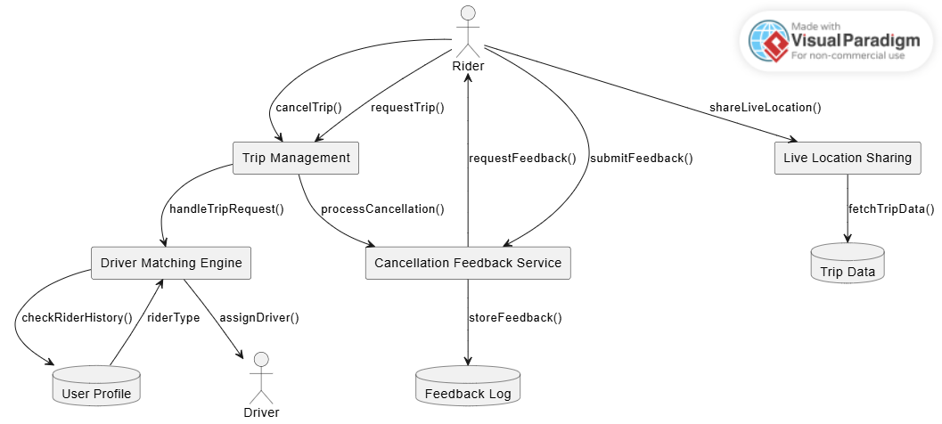

**Feature 2: SmartRide Assurance**

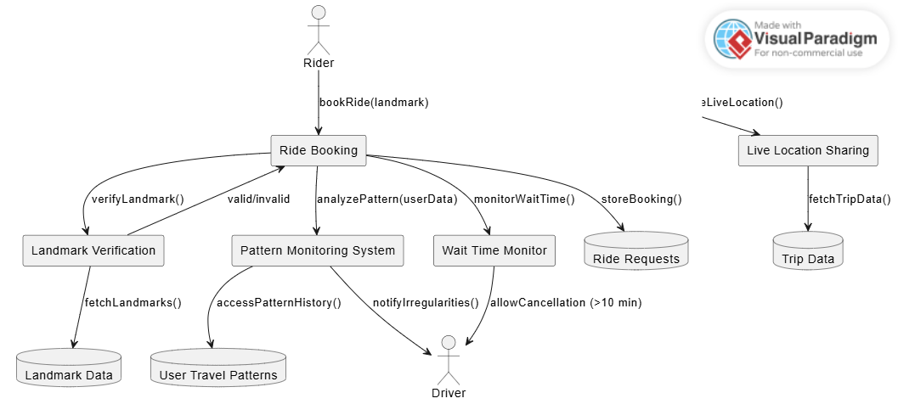

**Feature 3: Cancellation Control**

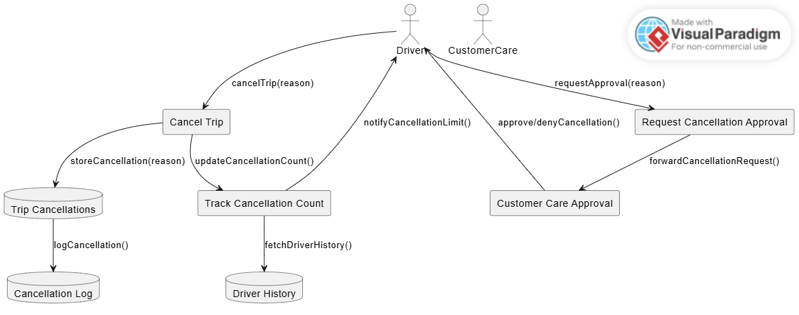

**Extra Features:**

**Moods:** As we have discussed the personas of the traveller based upon this we can introduce a feature called Moods, the objective is to divide the ride experience into these two personas

**Mood 1 - Regular:**

* This mood feature is for the Regualr commuters , it will already have the your home/office/other fed into this feature and your cab size of preference saved into it.
* The Rider just have to click one button to confirm a cab.
* The drivers for these cabs will have a higher rating and matched accordingly as per the feature 1 as above.

**Mood 2 - Traveller:**

* This mood feature is for the travellers/visitors, as per the booking of the cab they will have to mark the landmark in there booking, as they dont know whats the landmark we can implement the feature of most popular landmarks in your area and the map will showcase how much you are far from that landmark. Because of this it is easier for the driver and rider to locate each other.
* We can introduce the language of your driver, as it gets frustrating to talk to them , in a foreign language but it might extra time to reach the rider.

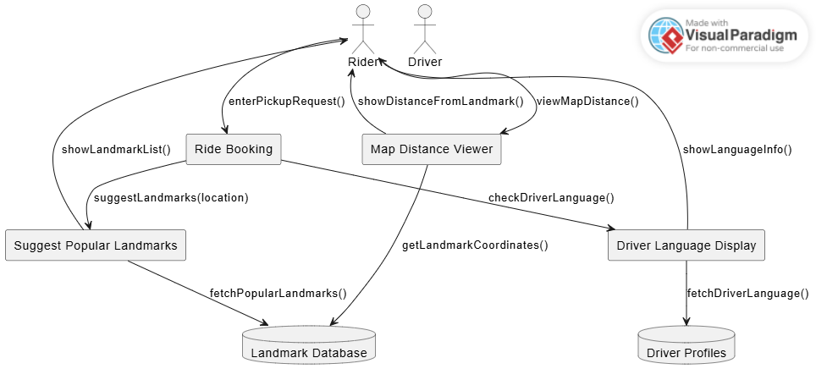

**Conclusion – Rider & Driver Experience Enhancement Features**

**SmartRide Assurance**

* Riders can cancel trips only within a time limit (e.g., 3 minutes).
* Repeat riders are prioritized with higher-rated drivers.
* Feedback is collected after cancellations.
* Riders can share live cab and driver location with others.
* UML DFD includes modules like TripManagement, DriverMatchingEngine, FeedbackService.

**SafeSpot Intelligence:**

* Riders must enter a landmark for easier pickup.
* Driver gets alerts for irregular rider patterns.
* Driver can cancel after waiting over 10 minutes.
* DFD includes LandmarkVerification, PatternMonitoring, WaitTimeMonitor.

**Cancellation Control:**

* Driver must enter a reason for cancellation.
* Only a limited number of cancellations are auto-approved.
* Beyond the limit, Customer Care approval is required.
* UML includes CancellationCountTracker, ApprovalFlow, CustomerCare.

**Traveller-Friendly Pickup Feature:**

* Riders are shown popular landmarks in their area.
* Map shows distance from selected landmark.
* Driver’s preferred language is displayed to avoid miscommunication.
* UML includes PopularLandmarkSuggester, MapDistanceViewer, LanguageDisplay.

**This Document discusses about the Cancellation problem that service is suffering from the past years, the saftey issues, pain points and Proposed features.**